**Shell- Final Case Study Assessment**

**Documentation**

**Scenario**: Streamline Solutions Inc. - Optimizing Software Deployment

**Problem Statement**: Implementing a Seamless CI/CD Workflow for a Spring Boot Application using Azure Boards, Azure, Git, Maven, Docker, GitHub, GitHub Actions

**Submitted By- Tanya Yadav**

**Employee Code- 654952**

**Reg ID**- SH7B23242

**Shell – Final Case Study Assessment**

**Task1- Project Management Setup:**

Establish Azure Boards to manage the Agile/Scrum project's progress, including creating a Project Board, Backlogs Board, Sprints/Iterations and Tasks Board.

Created project-

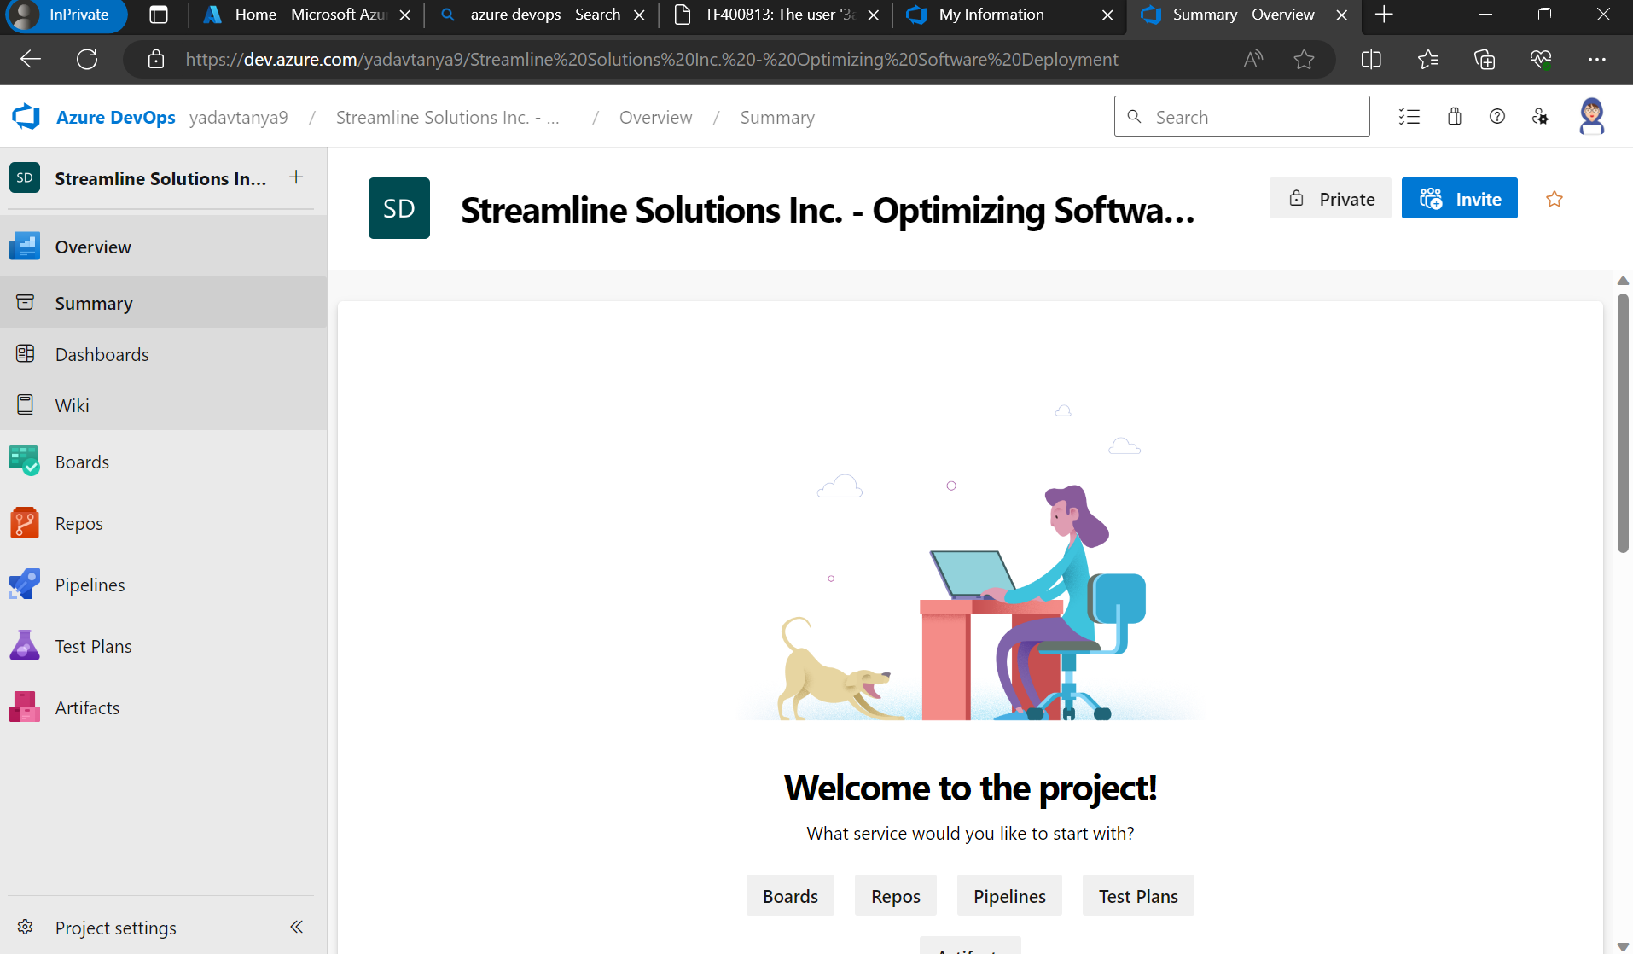

Created tasks, user stories, features, epic.

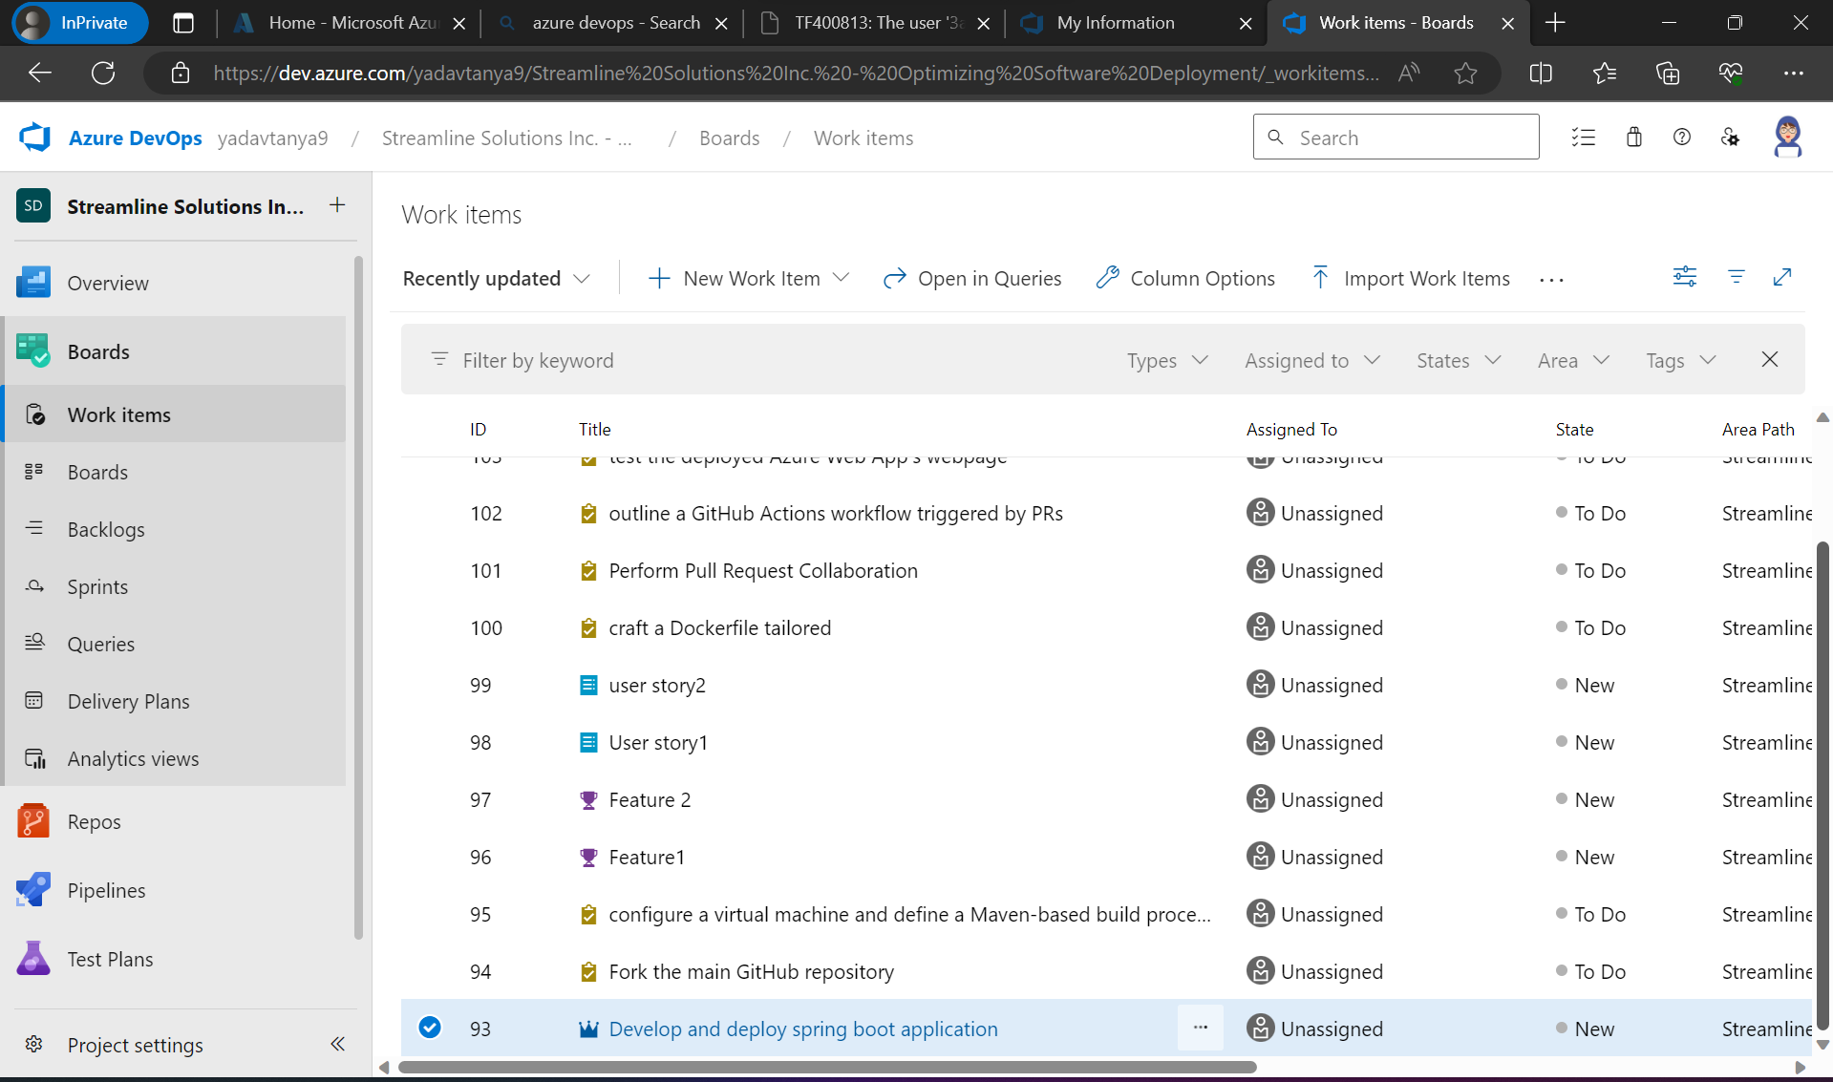

Created hierarchy-

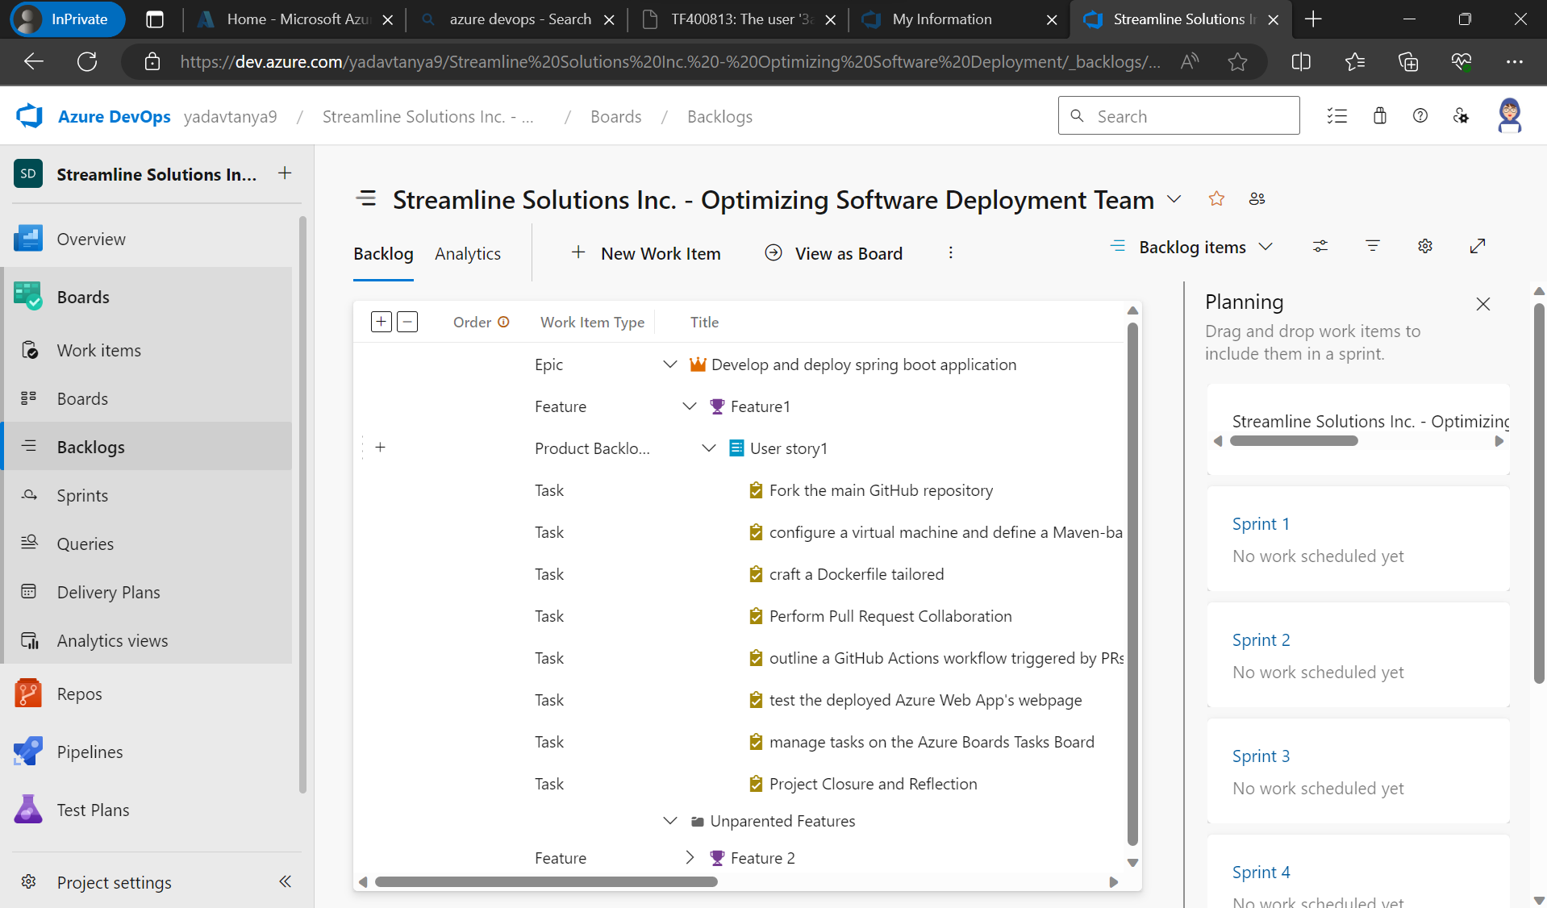

**Sprints view-**

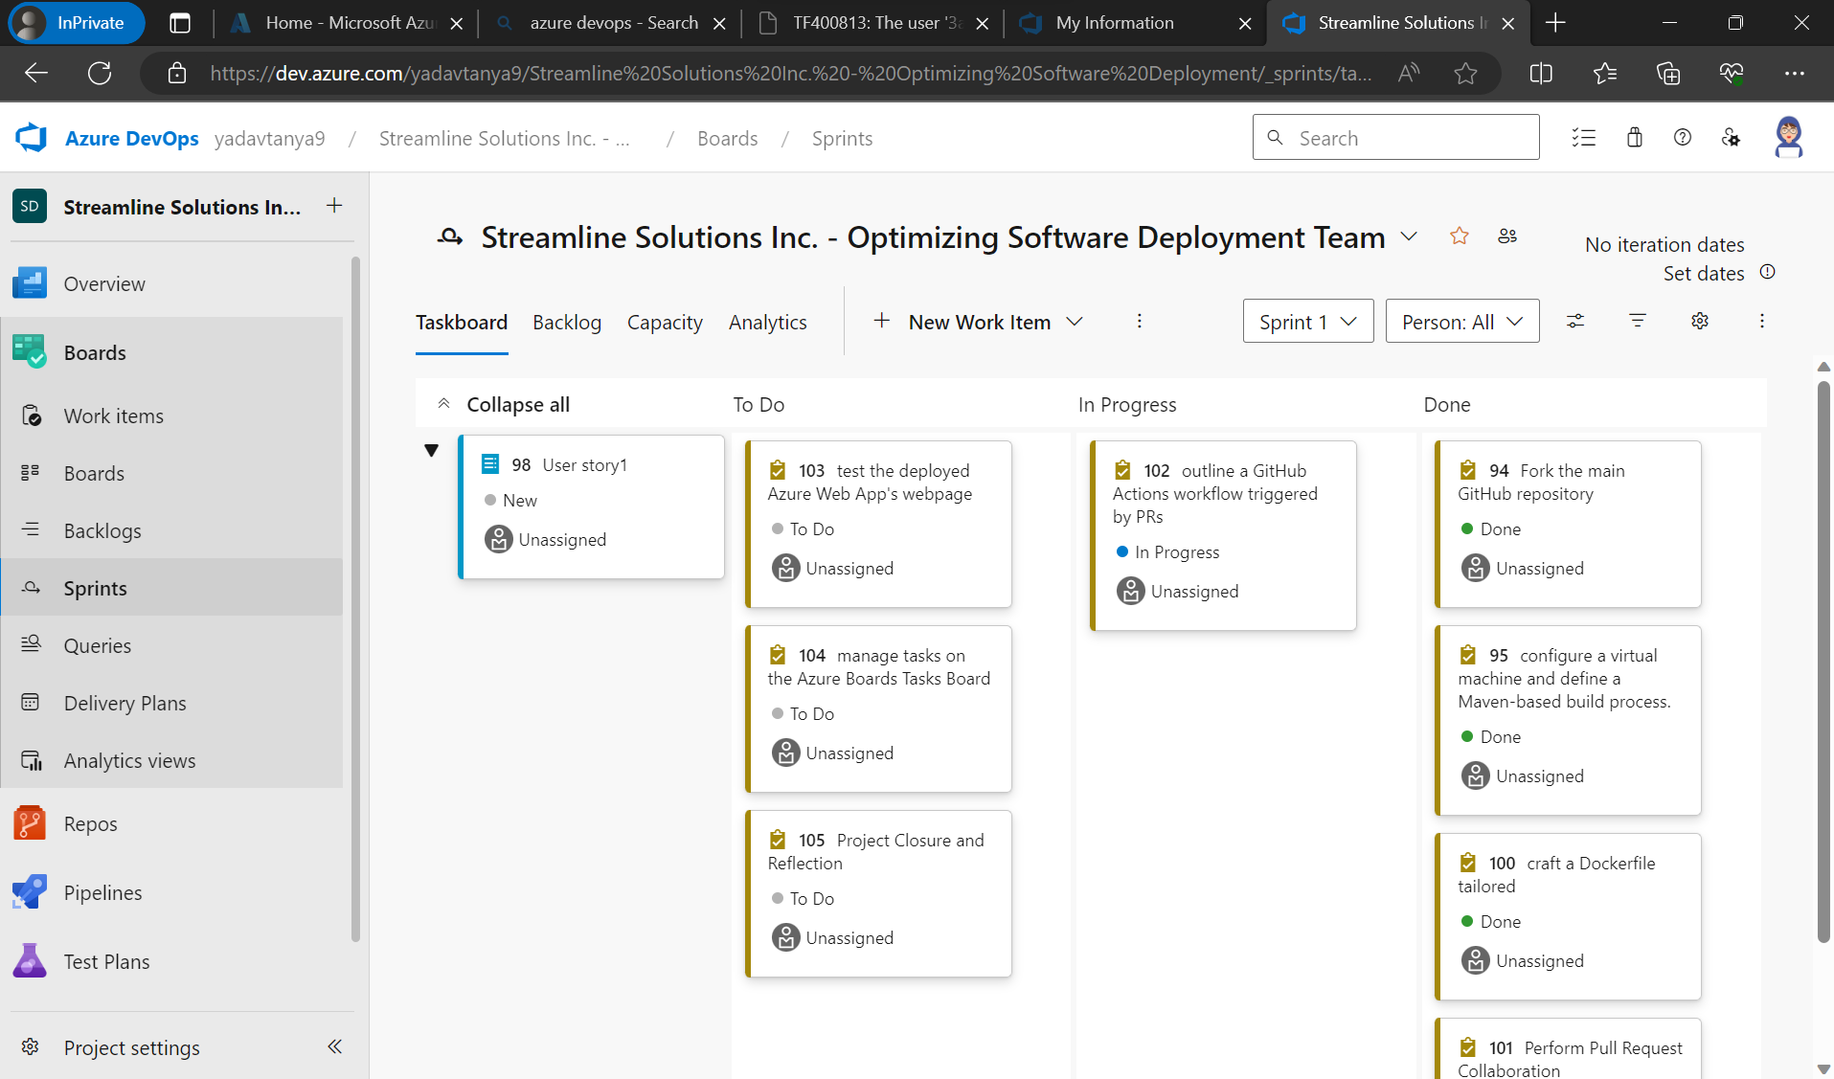

**Task2- GitHub Repository and Feature Branching:**

Developers will fork the main GitHub repository (https://github.com/hrb1989/shell_7_foundation_Java_Spring) into their local environments. They will create feature branches to work on specific enhancements or tasks related to the Java Spring Boot application.

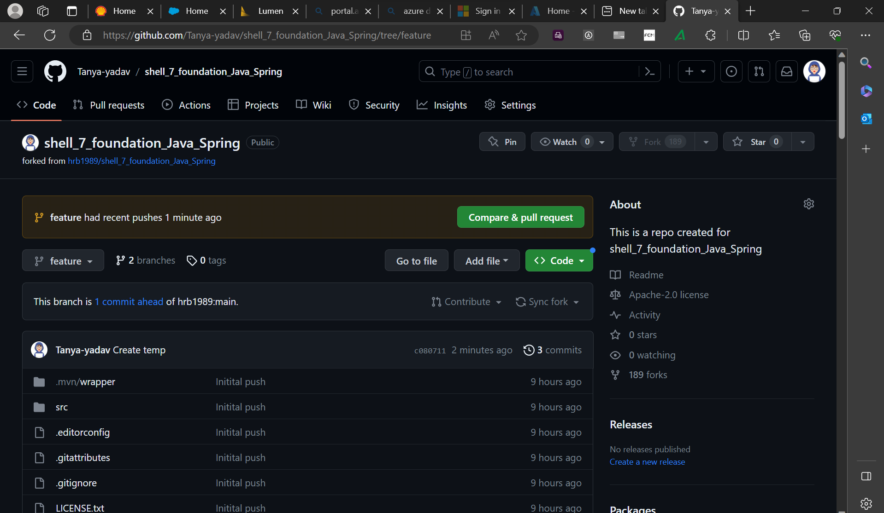

**TASK3- Azure VM Configuration:**

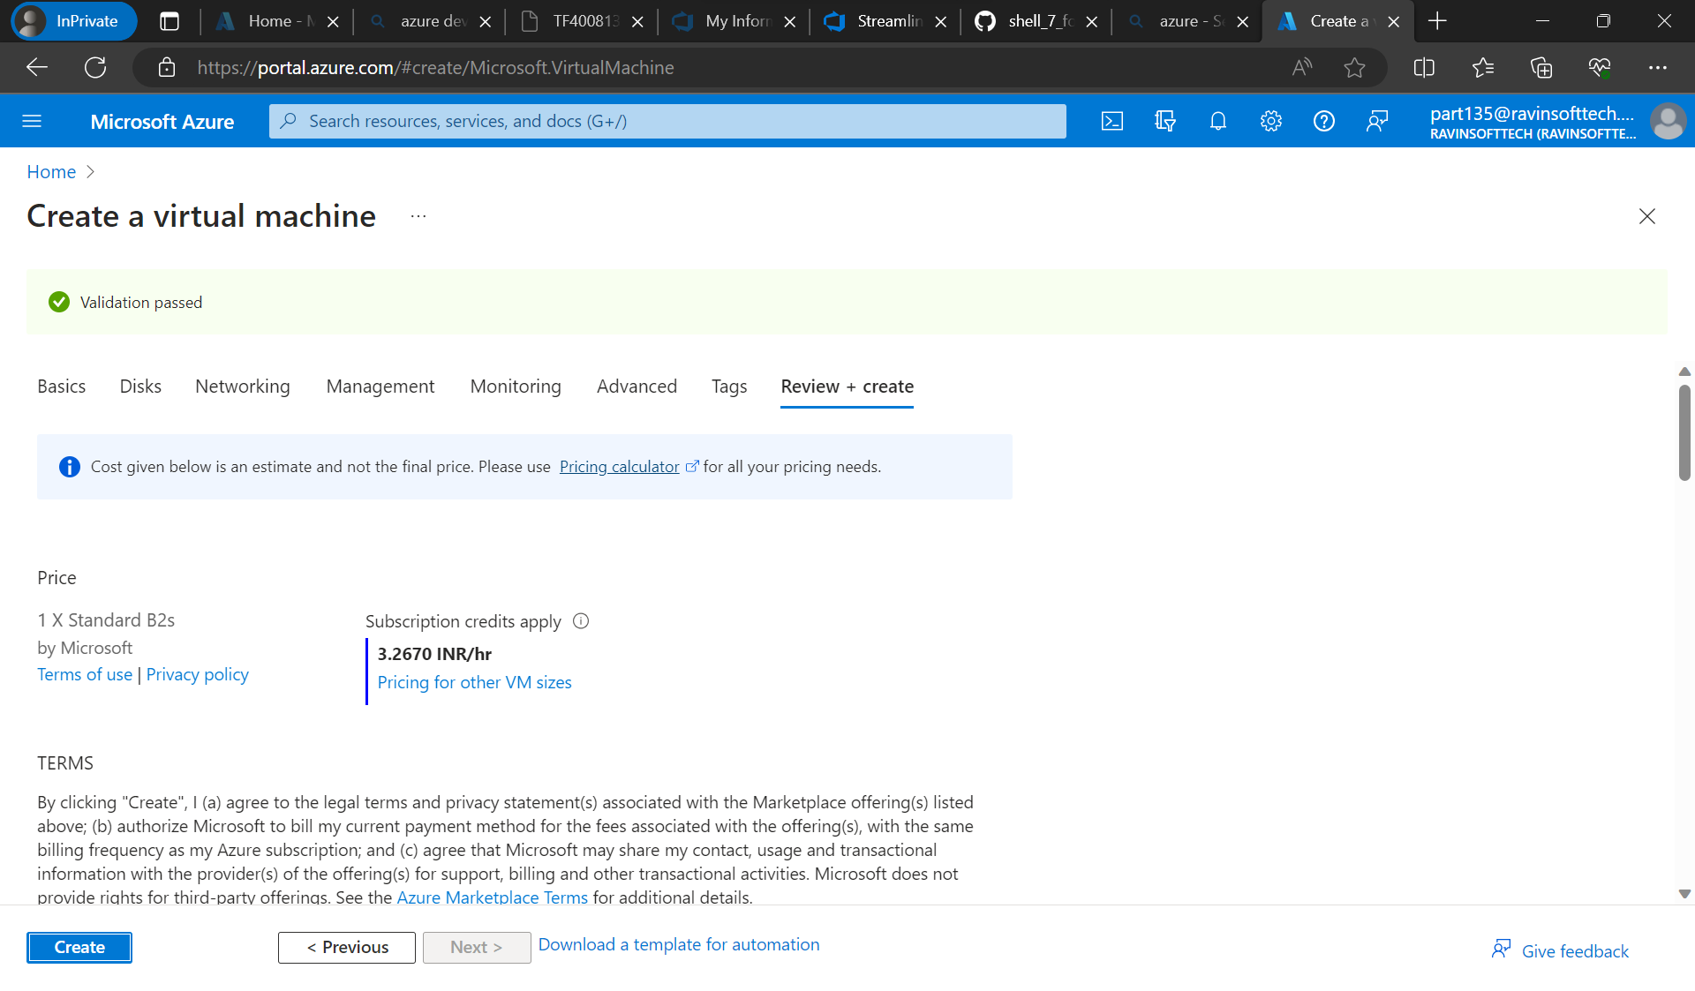

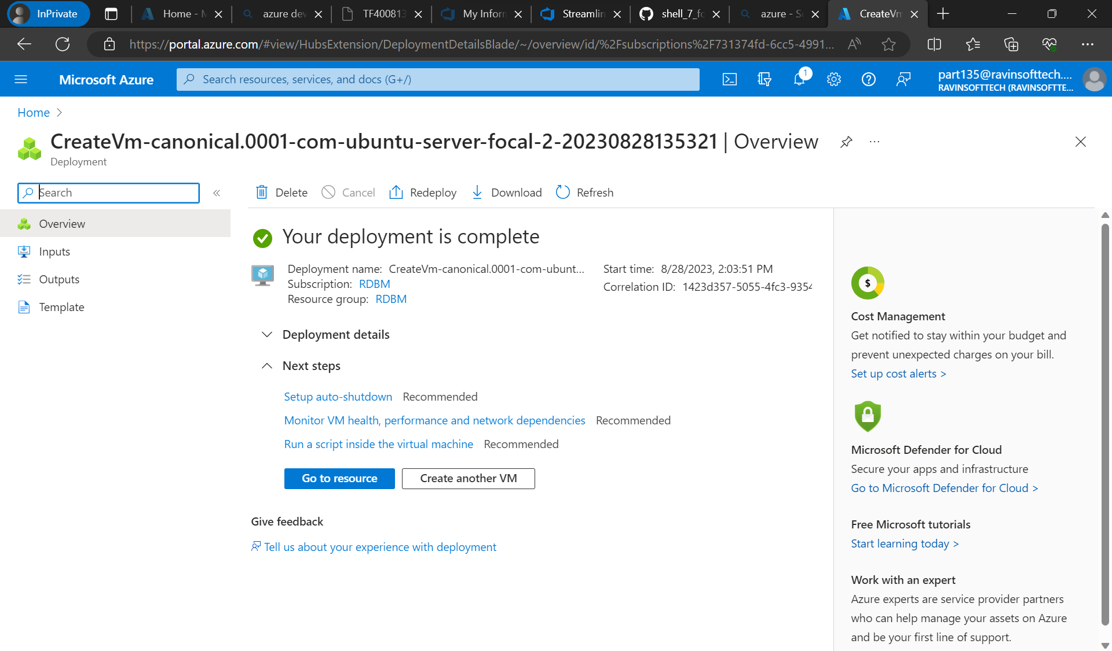

**TASK4&5 - Maven-Based Build Process and Prometheus Monitoring Integration:**

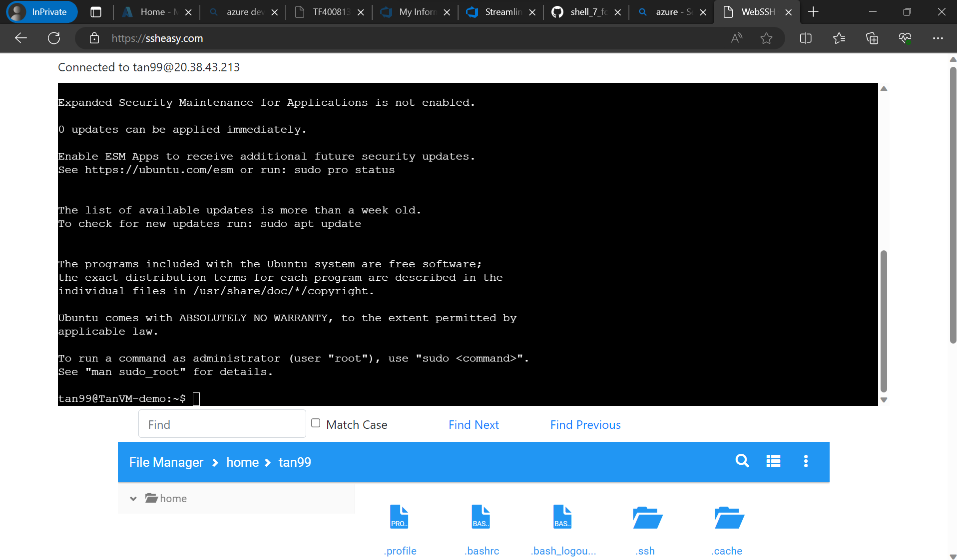

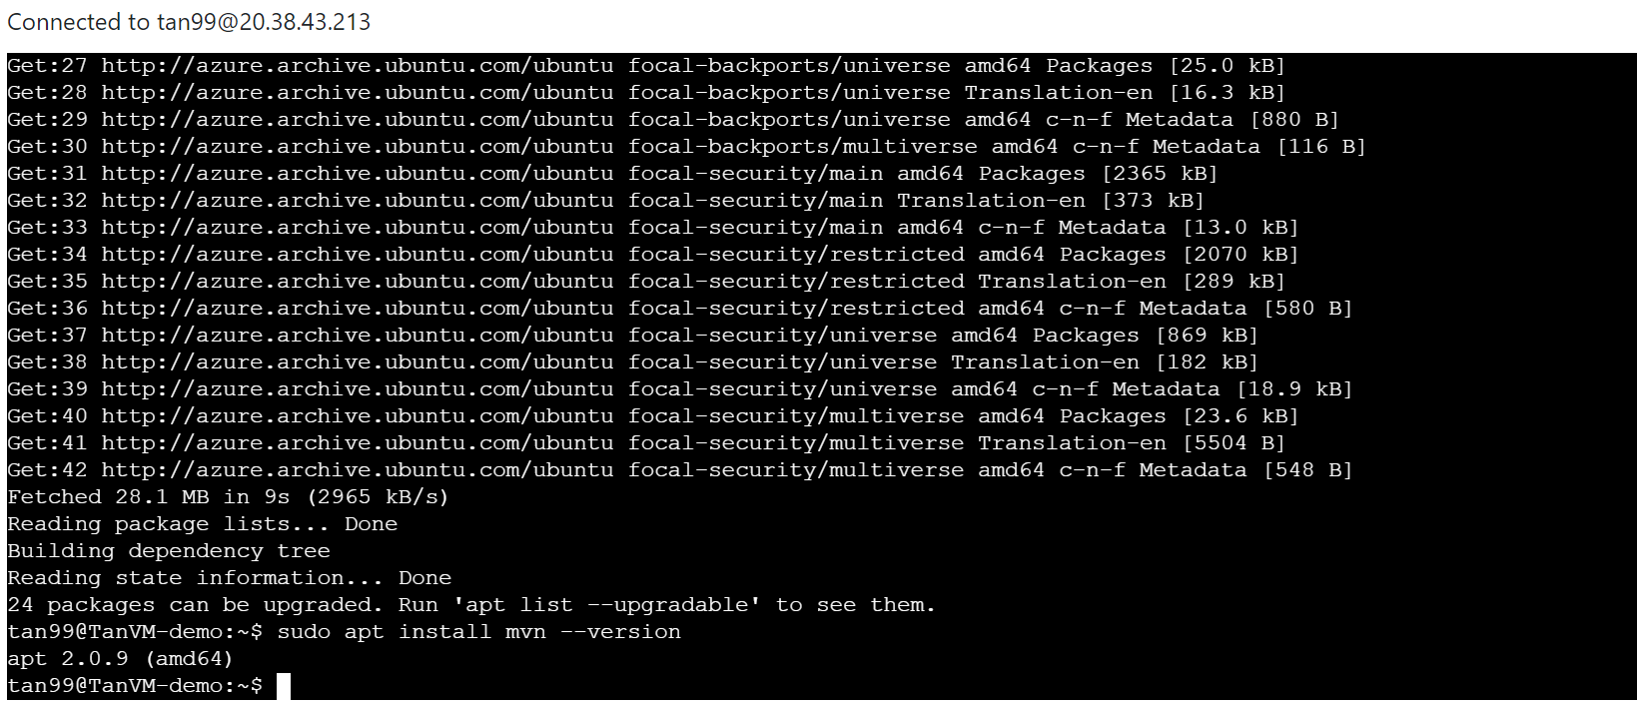

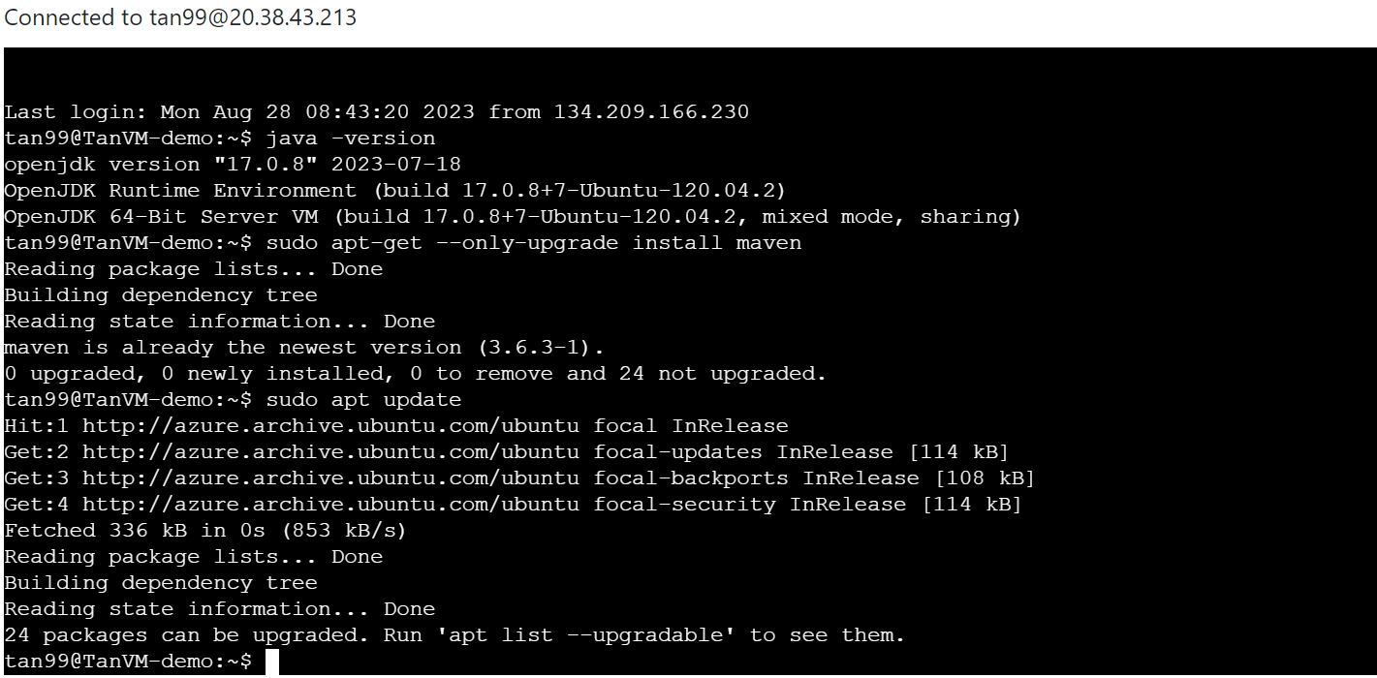

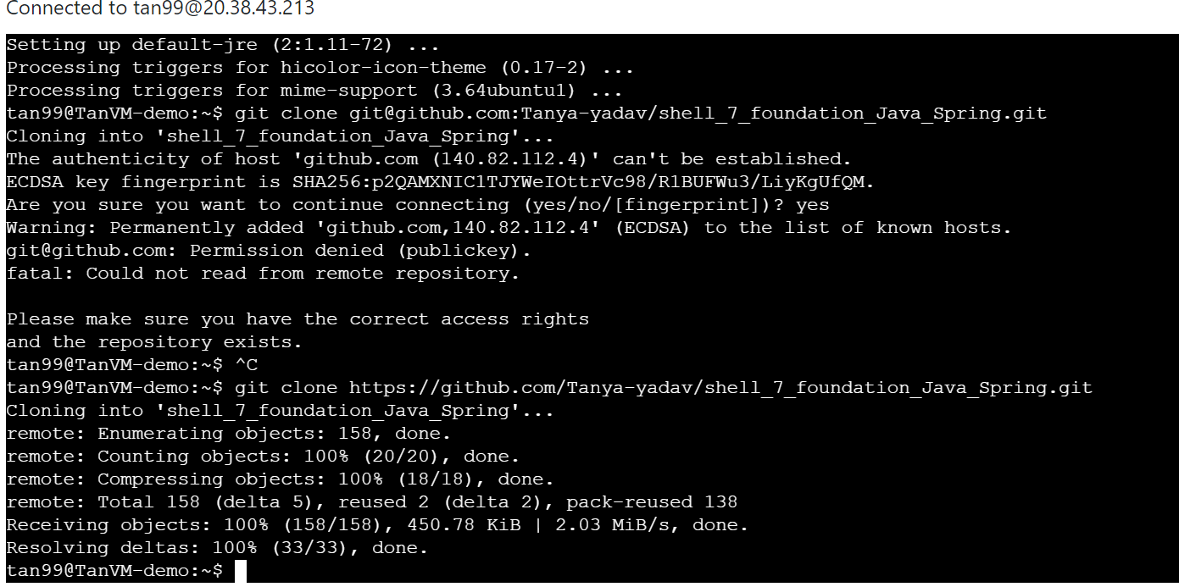

**Prometheus Monitoring Integration:**

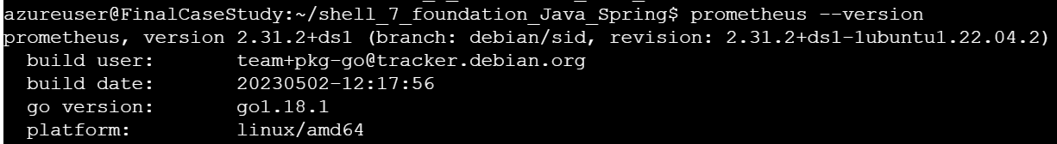

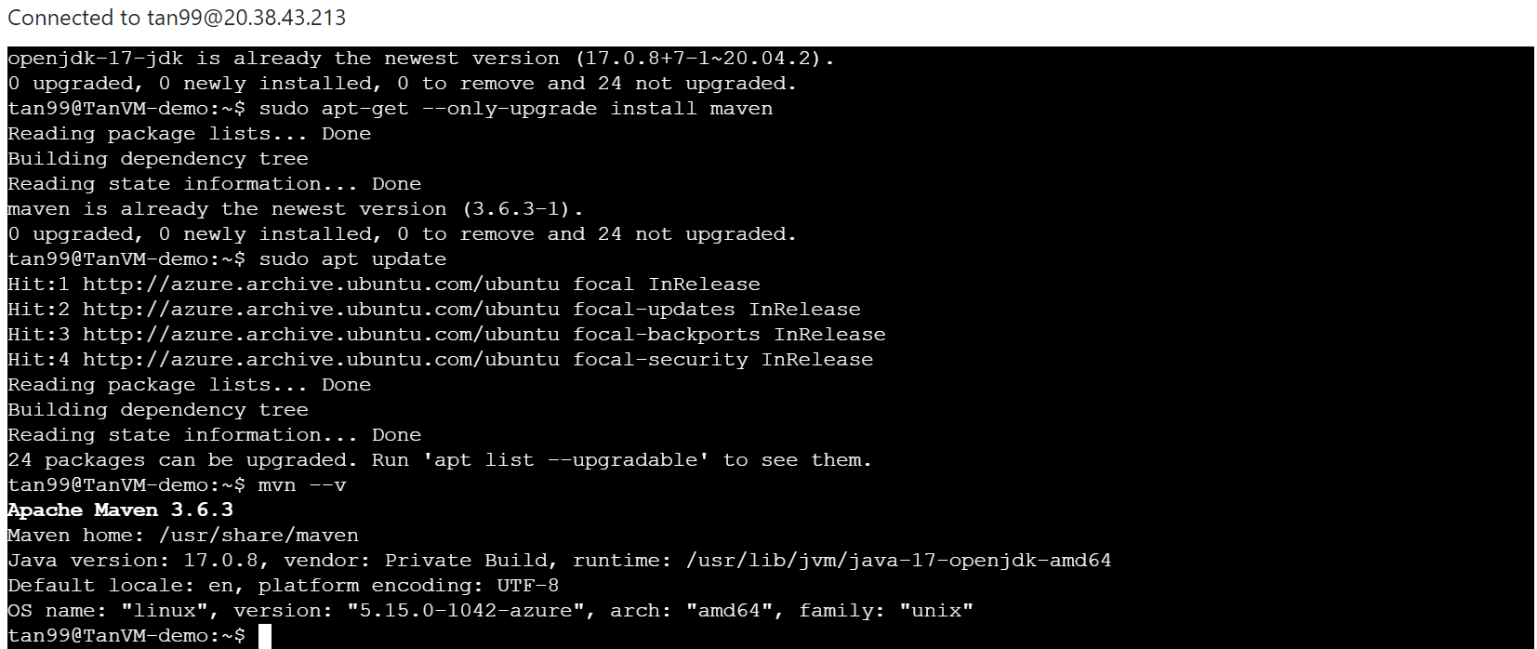

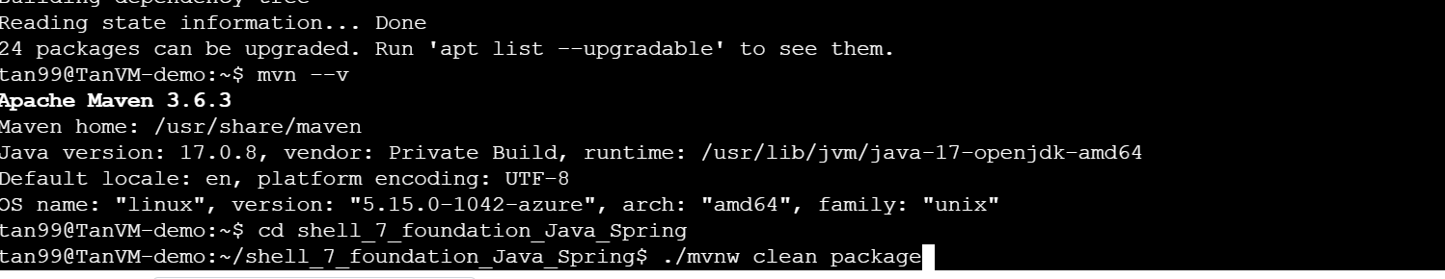

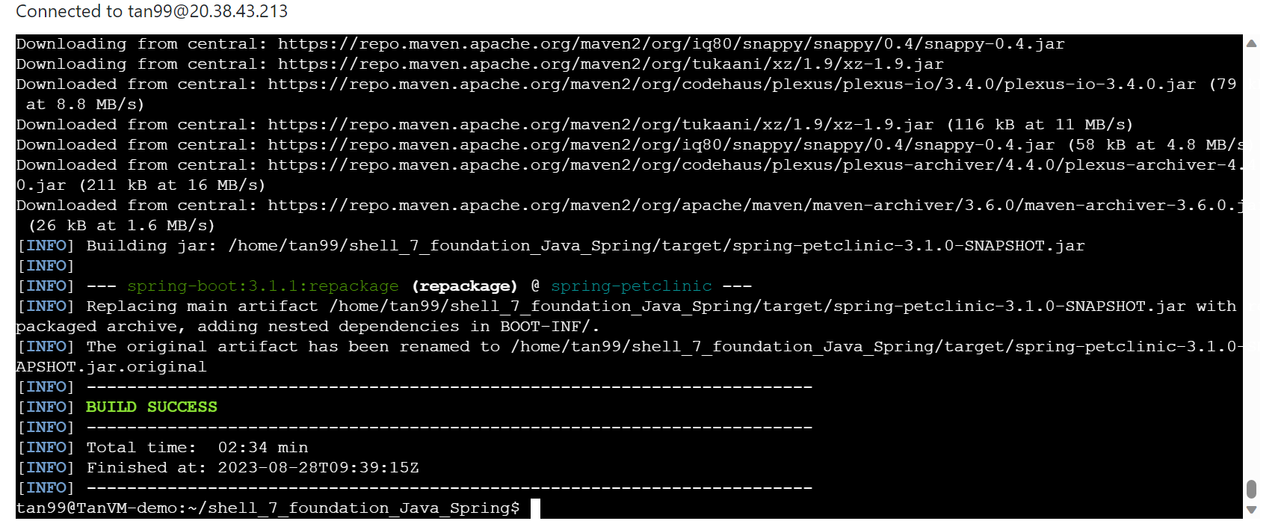

**TASK6- Docker Containerization:**

Next create docker file using: vi dockerfile

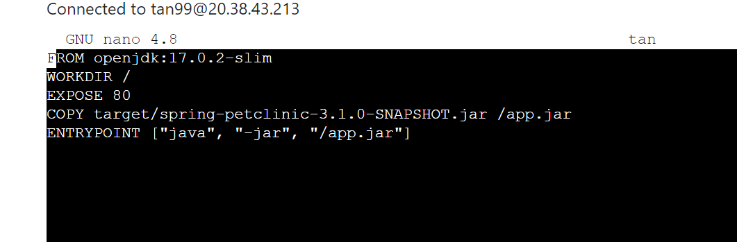

**TASK7- Azure Web App Configuration:**

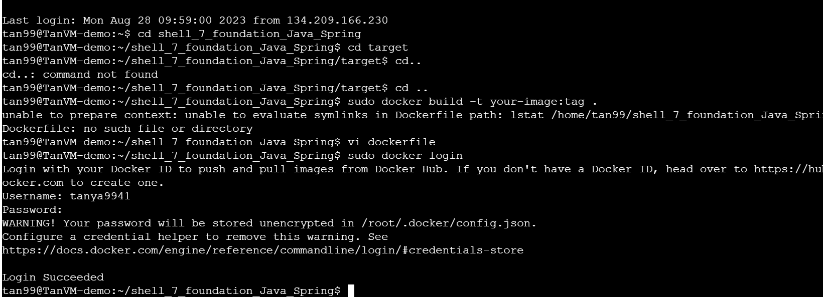

**TASK8- Pull Request Collaboration:**

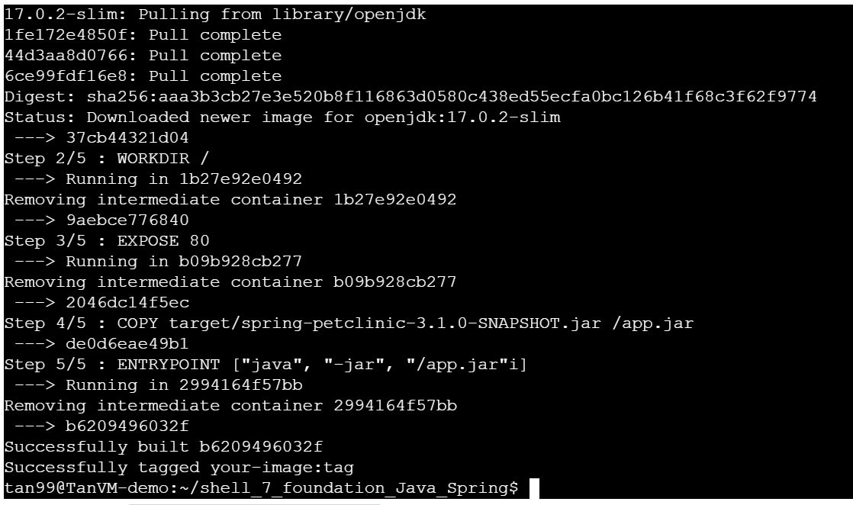

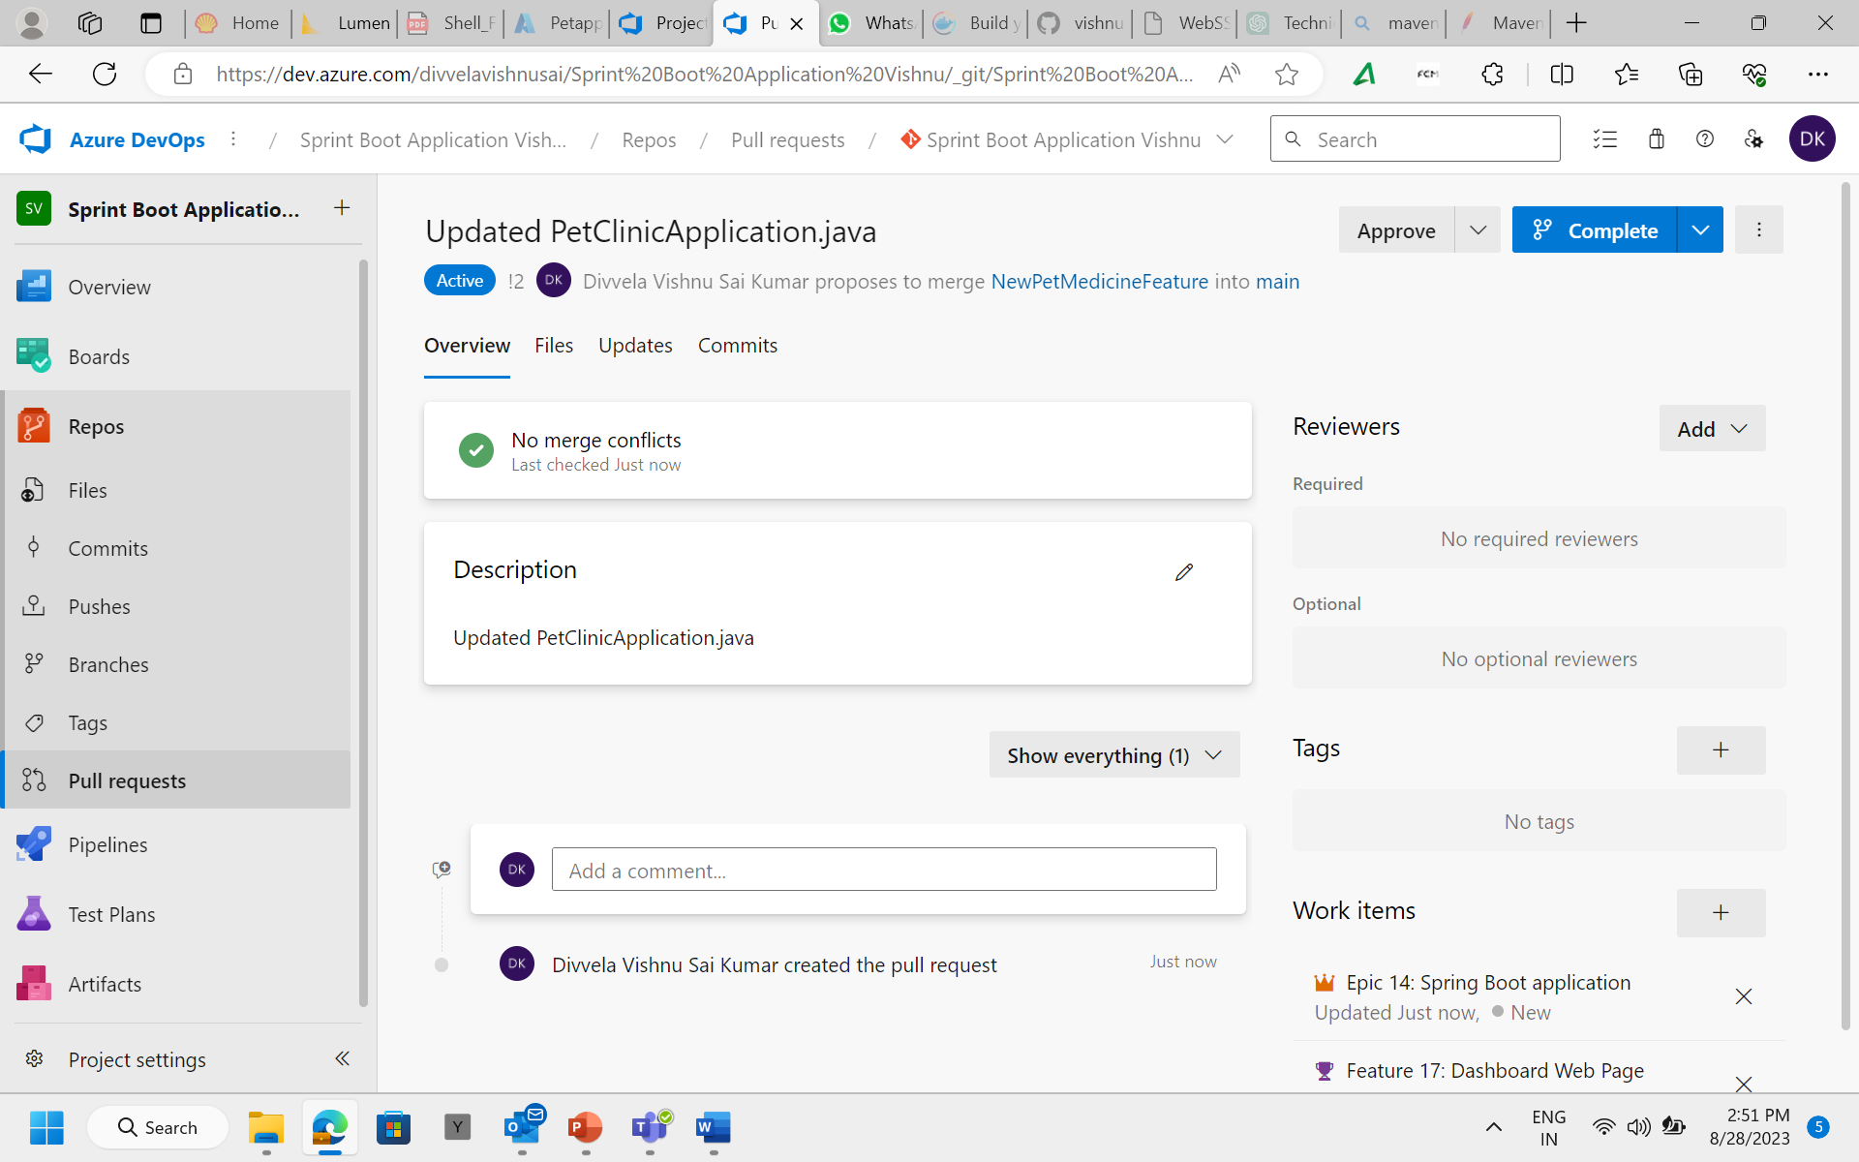

**TASK9- GitHub Actions Workflow Implementation:**

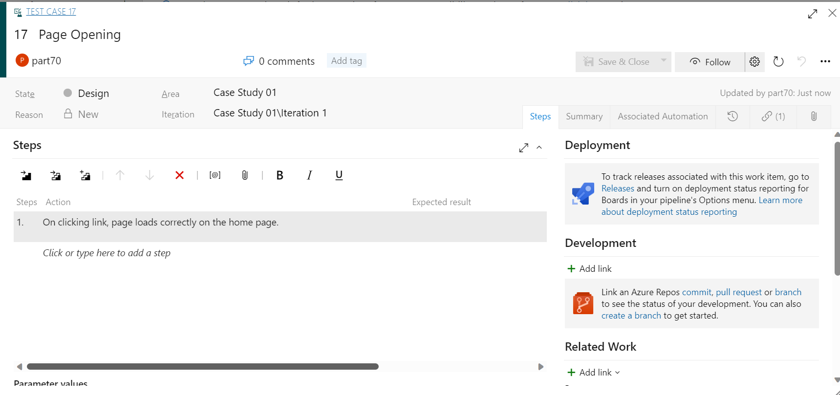

**TASK10 - Azure Boards Tasks and Sprint Closure:**

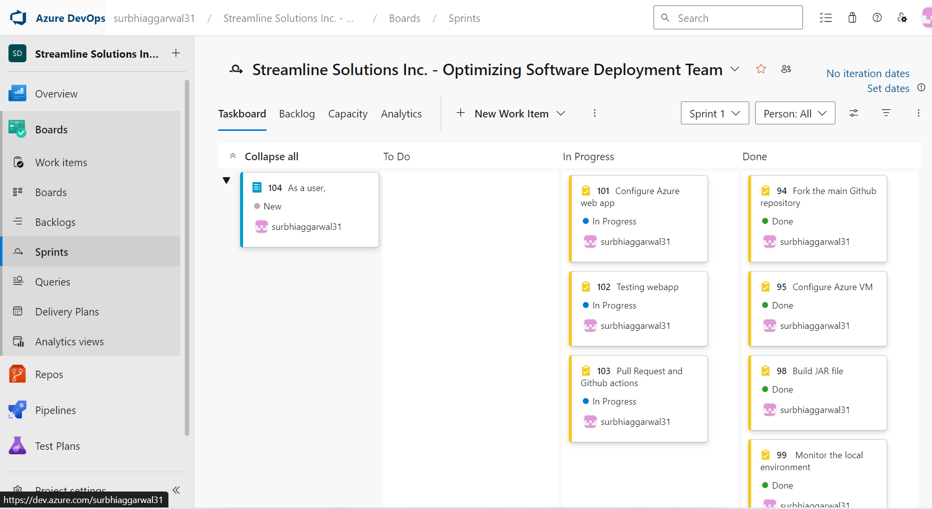

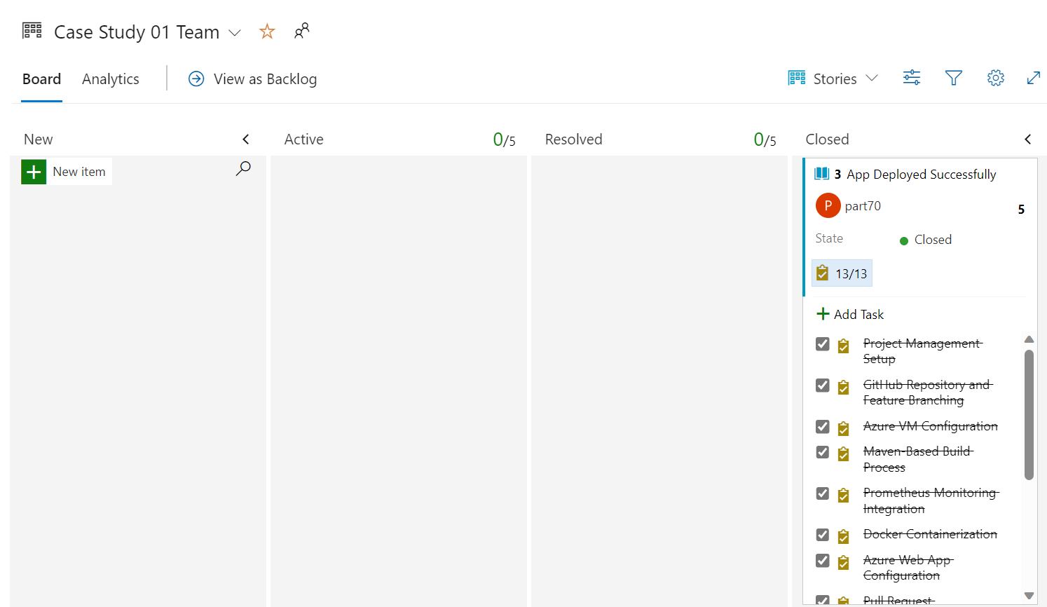

**TASK11- Outcome**

I've learned how to work with a sprint, and having implemented the app in tight timeframes, it has taught me time management skills as well as my ability to manage pressure. I learnt about deploying an app on azure, created a dockerfile and docker image, devops, agile, git, github workflow, etc. Streamline Solutions Inc. aims at delivering rapid and reliable software deployment, since the CICD Workflow has been systematically implemented.